Name: | Date: | Period:
CURRENT EVENT
Source Information Choose an article from a reputable news source at least once a week during the time we are away from school.
Title & Article Link
Author: | Source: | Date Published:

Summary: Word Count: 200+
In your own words, summarize the current event to demonstrate a real understanding of the article with thoughtfulness and accuracy. In your summary, underline how people have been affected or will be affected in the future.

Reflection: Word Count: 75+
Questions to consider: Why is this important? What questions are left unanswered? What bias is present in the article? What are your own thoughts and feelings? What should be done?

©History to the Core and More

Enduring Issue
Identify & define one Enduring Issue present in the article.

Briefly explain how the Enduring Issue applies to the article.

Connection
Explain how the article is connected to something else you have learned.

Geography
Identify the country/countries or region(s) mentioned in the article.

Locate the country or region on the map below.

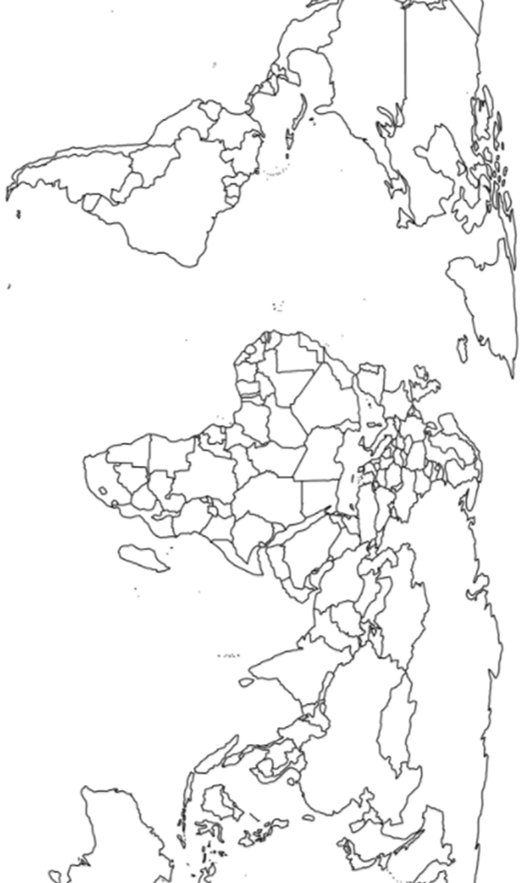

Don’t forget:
- Check your word count, spelling, and grammar throughout this form
- Share what you’ve learned with your friends and family!
- Email it to Mrs. Chelsi at cdemastes@k12.wv.us

